**ILPA Members feedback on UKVI Coronavirus communication – collated on 31st January 2020**

1. Please can we also ask UKVI whether there is a possibility of those currently in the UK under a Tier 4 (General) visa category, not meeting the requirements for the in country switch, to apply in the UK on exceptional basis or commence their employment on a Tier 4 (General) visa?
2. Many thanks for the update as I have had a few queries relating to this. One query that we have is that it is no longer possible to obtain police clearance certificates in Hong Kong because of the coronavirus:

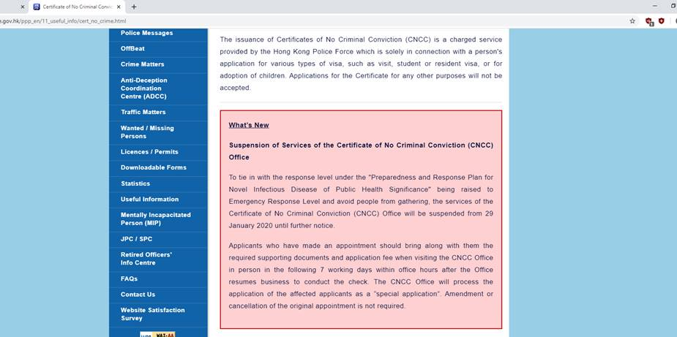

It would be helpful to have confirmation from the Home Office that they will accept applications without providing the certificate if possible. The Rules would seem to allow for this as they state:

(f) Where the applicant is 18 years of age or older, the applicant must provide a criminal record certificate from the relevant authority in any country in which they have been present for 12 months or more (whether continuously or in total) in the past 10 years, while aged 18 or over. **This requirement does not need to be met where the Secretary of State is satisfied, by way of an explanation provided in or with the application, that it is not reasonably practicable for the applicant to obtain a certificate from the relevant authority.**

 However, it would be helpful to have confirmation of this to avoid any issues with processing or when encountering staff at the Visa Application Centre.

1. Other issues for the guidance:

* The position relating to any immigration and nationality applications with residence requirements.
* The position of those who have been granted entry clearance but who have been unable to arrive in the UK within the time period on their vignette.

1. Dear ILPA,

Thank you for circulating the UKVI’s response to outbreaks of Coronavirus in China.

We currently have these concerns from our clients and the public:

* Anyone who holding visitors visa in the UK and who are approaching to the end of their 180 days, what measure would be for this group;
* People who have scenarios that they have to leave the UK within 30 days after their unsuccessful application/overstaying and to apply for a subsequent application from China;
* People who are waiting to submit their biometrics in China VACs after already submitted their online applications;
* People who are planning to submit their visa application in China immediately;
* Will applicant whose residence in different provinces in China be differentiated for their applications; and if people use different addresses to hide their residences in high risk province/cities, would there be treated as deception?

These are immediate questions, concerns from my contacts, and I will continue to collect feedbacks from my source. Thanks for your kind assistance.

1. Nicole

Thank you for this incredibly timely and helpful update.

**Taiwan – VAC open but delays in sending/receiving documents to/from mainland China**

The VAC in Taiwan is currently still operating and the staff there are immensely helpful. For any Chinese applicants in the Asia-Pac area this could be a useful alternative biometric location if they can make it there. The one catch is that until yesterday (it may still be the case now) the passports were going to/from the decision making centre (DMC) in mainland China, causing delays in transit as international couriers/diplomatic staff may be working at reduced capacity within and from China.

One solution to the delays in transit to/from the DMCs in China would be to divert documents for visa printing to another DMC in the region, such as Manila,  Singapore, etc.

**Tier 2 applicants**

It would be great if the policy could clearly set out a blanket indefinite waiver for sponsors to the usual 28 day maximum delay to the work start date stated on the CoS for decisions made by the Chinese DCMs (without having to seek authorisation/approval on a discretionary basis for each individual). This is because my client, once he eventually receives his passport and arrives in the UK from Taiwan, will likely be in self-quarantine for two weeks and unable to present for work at his UK employer’s office to complete right to work checks, and start the role.

**All overseas applicants**

It would also be most helpful if the replacement temporary vignettes for travel could be replaced free of charge if they have already been issued and the individuals unable to travel within the window specified when they applied because of travel restrictions in their region, and also BRPs retained by the receiving Approved Collection Locations for more than the usual 30 day window to allow for travel delays.