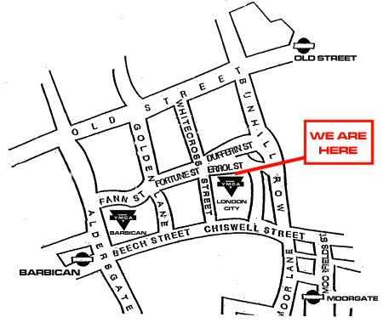

London City YMCA
8 Errol Street, EC1Y 8SE

How to find us
Depending on the direction you are travelling from, take the underground to either Old Street (Northern Line and suburban rail services), Moorgate (Northern, Hammersmith & City, and Metropolitan Lines), or, Barbican (Circle, Hammersmith & City, and Metropolitan Lines).
The nearest Main Line rail station is Liverpool Street which is a walk-able distance if you don not have a lot of luggage, otherwise take the underground to either Moorgate or Barbican.
If travelling on Thameslink you should alight at Farringdon and take the underground to Moorgate or Barbican.

