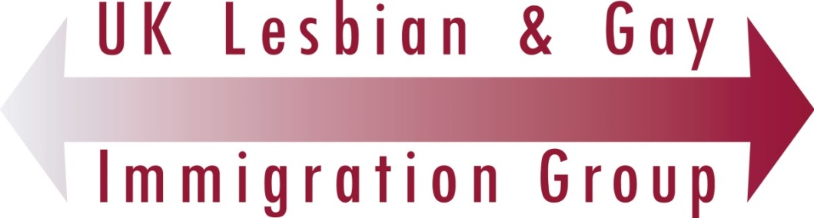

MONITORING FORM

We ask you to complete this form in order to continue to demonstrate our commitment to equality and diversity. The forms are anonymous and you are under no obligation to complete one but we are grateful if you do. The information plays no part in selection process.

Position applied for:

Date:

Are you? (Tick as appropriate) Female Male Trans Non-binary Intersex Other Prefer Not to Say

Are you? (Tick as appropriate) Heterosexual Lesbian Gay Bisexual Queer Prefer Not to Say

Which one of the following age groups are you in?
Under 25
25 – 35
36 – 45
46 – 55
56 – 65
Over 65
Prefer Not to Say

Which of the following ethnic backgrounds do you consider yourself to belong to?

Ethnic origin is not about nationality, place of birth or citizenship. It is about the group to which you perceive you belong. The ethnic groups are standard categories for collecting ethnic group information in line with the guidance from the Office for National Statistics and the Equality and Human Rights Commission. The list of groups is designed to allow most people to identify themselves. The list is not intended to leave out any groups of people but to keep the collection of ethnic information simple.

Please chose one section by ticking a box against it and also where applicable tick the appropriate box

White
English Welsh Scottish Northern Irish Irish
British Gypsy / Irish Traveller Prefer not to say
Any other white background, please write in:

Mixed/multiple ethnic groups
White and Black Caribbean White and Black African White and Asian Prefer not to say Any other mixed background, please write in:

Asian/Asian British
Indian Pakistani Bangladeshi Chinese Prefer not to say
Any other Asian background, please write in:

Black/ African/ Caribbean/ Black British
African Caribbean Prefer not to say
Any other Black/African/Caribbean background, please write in:

Other ethnic group
Arab Prefer not to say Any other ethnic group, please write in:

Where other ticked, please write in:

Prefer Not to Say

Disability

Many people who do not consider themselves to be disabled may be covered by the Equalities Act 2010 because they have a health condition that has an impact on their lives.

What do we mean when we say disability
Disability is a physical or mental impairment, which has a substantial and long-term adverse effect on a person’s ability to carry out normal day-to-day activities.
Do you have a physical or mental impairment or long term health condition?
Is this expected to last, or has it lasted, for a year or longer?
Does this make it difficult for you to do the things that most people do on a fairly regular and frequent basis?
For a comprehensive definition of disability including examples please refer to
https://www.gov.uk/definition-of-disability-under-equality-act-2010

Do you consider that you are disabled as defined by the Equalities Act 2010?

Yes
No
Prefer Not to Say

What is your religion or belief? We understand that below is a list of religions commonly found in Britain. They are in alphabetical order and not intended to signify rank in terms of importance. We realise that the list is not exhaustive and if your religion is not specifically listed we ask that you do not take offence as none was intended.
Buddhist Church of England Hindu Jewish Muslim No religion or belief Other Roman Catholic Sikh Prefer not to say

If other religion or belief, please write in:

What is your current working pattern?
Full-time Part-time Prefer not to say

What is your flexible working arrangement?
None Flexi-time Staggered hours Term-time hours
Annualised hours Job-share Flexible shifts Compressed hours
Homeworking Prefer not to say If other, please write in:

Do you have caring responsibilities? If yes, please tick all that apply
None Primary carer of a child/children (under 18)
Primary carer of disabled child/children
Primary carer of disabled adult (18 and over) Primary carer of older person
Secondary carer (another person carries out the main caring role)
Prefer not to say

Where did you see this post advertised/how did you learn of this position?

Thank you for your help in completing this form. Please send it with your completed application form to recruitment@uklgig.org.uk.

Privacy Notice: Your privacy and data protection

In order to recruit and manage staff, UKLGIG needs to store personal information (data) about all applicants. UKLGIG is registered as a “controller of personal data” with under the Data Protection Act 2018 with the Information Commissioner. By filling in this form you accept that we will keep the information on this form. UKLGIG keeps all personal information safely and securely, and does not share your information with anyone outside UKLGIG or any other organisation without your consent. Information is kept for the minimum period necessary which for this form is 6 months after the conclusion of the recruitment campaign.

You have a right to request access to the information that we hold about you and you have other rights to protect your information. More details are available from any member of UKLGIG staff.

