ILPA membership – why you should join us!

This info sheet is a quick reminder for non-members of ILPA of why you should join and what you can get out of ILPA membership.

More information is available on our website at https://www.ilpa.org.uk/pages/ilpa-join-us.html

And get in touch at any time to talk it through info@ilpa.org.uk

"I am finding the membership very useful. So much is changing at the moment and it is good to both have a repository of knowledge about what the different changes mean for us as practitioners and to be part of a professional voice that tries to advocate on behalf of clients and practitioners." - new ILPA member, February 2019
"A very friendly environment where ideas are exchanged. Excellent knowledge by very enthusiastic members" - ILPA members survey Jan 2019

ILPA members can now display this logo to show their membership.
Joining ILPA is your chance to get involved alongside leading practitioners, in improving the quality of immigration advice and representation and in influencing the development of the law.
"the updates help us to stay on top of an area of law that is always changing" - ILPA Members survey January 2019
ILPA membership is open to those who are substantially engaged or interested in the law. Those giving advice and representation must be regulated by a recognised professional body, with a code of conduct and the power to discipline its members. Full details are set out in Articles 3 and 4 of ILPA's Articles of Association. Membership is open to individuals and organisations and the categories of membership are set out in the membership application pack. Members must adhere to ILPA's Guidelines for members.
See our categories of membership and fees applicable.
"essential for me, extremely valuable" - ILPA Members survey January 2019
You can join as an individual, or as an organisation (under which anyone at your organisation would be considered a member). The membership form will be reviewed by the Committee of Trustees who meet once a month so there may be a delay of a few weeks.
Did you know you can attend training at the members’ rate (according to the category you are applying at) whilst your application is pending? (If your application is not successful, you would be liable for the full non-member fee).

Benefits of membership
As a member, you will benefit from:
- reduced rates for all ILPA training: ILPA’s extensive programme of training, conferences and networking events is provided by members and experts and offers the opportunity to stay abreast of best practice in discrete specialist areas of immigration law - keep up your Continuing Professional Development record - volunteer to train
- a listing in ILPA’s Directory of Members;
- advertise your membership using our 'member of ILPA' logo
- ILPA’s monthly mailing updating you on new developments and providing you with information not available elsewhere; and access to the online archive of mailing enclosures and a wide range of other documents (read a sample of our mailing and key documents listing); if you would like to receive a sample copy by post request to info@ilpa.org.uk
- email alerts on developments of importance;
- opportunities to participate in specialist members-only working groups, through e-groups and meetings;
- free copies of ILPA publications including best practice guides;
- opportunities to become involved in ILPA's influencing work working alongside leading practitioners in the field to represent ILPA at meetings, provide evidence to parliament and in response to consultations run by government departments and others;
- access to ILPA’s library by appointment;
- a say in how ILPA is run.

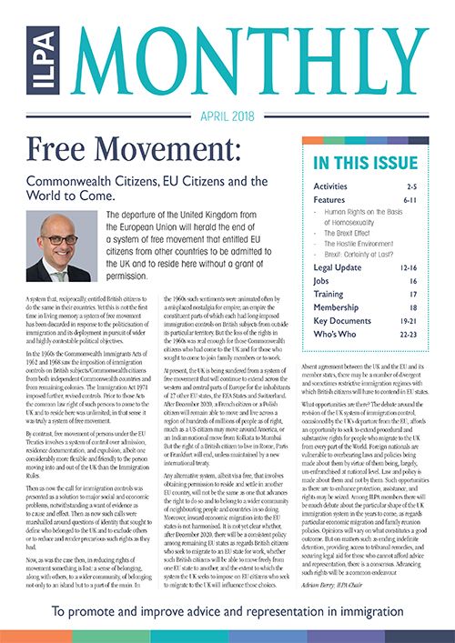

ILPA was founded in 1984 and remains true to the principles of its founders, as set out in ILPA’s Memorandum and Articles of Association. These describe our work to promote standards of best practice, and the breadth of all of all our activities.
We work across all areas of immigration, asylum and nationality law, concerning migrants from all countries of the world, without discrimination.
Members share and disseminate information and views on immigration, asylum and nationality law and practice in the United Kingdom and beyond.
ILPA members communicate by email as well as face to face and through meetings and mailings. Members share information and views with other members; contribute to ILPA's monthly mailing, to working group email groups and to discussions. ILPA’s strength is that all members support each other. Members’ contributions are also what make ILPA’s influencing work so powerful, as members feedback their views to those making decisions on law and practice.
ILPA highly-regarded training sessions are an opportunity for trainers and attendees to share in a collaborative project to improve knowledge and standards of practice. They are unique. We also team up with others, in the UK and overseas, for training and conferences. Members contribute to training sessions as attendees and as trainers, and suggestions from members inform the development of ILPA's training programme.
The special character of ILPA is that practitioner members do not simply voice their own interests but the interests of clients and of a just and equitable, non-sexist and non-racist immigration, asylum and nationality law practice. ILPA uses its powerful voice in influencing work to speak up for the rule of law and for people under immigration control. ILPA members have frequently spoken up for measures that will make their own lives as practitioners more difficult, because these measures would be better for people under immigration control. Opposition to racism and sexism in immigration, asylum and nationality law and practice informs all ILPA’s work.
We hope that you will want to be part of that project and look forward to receiving your application.

